

Mrs. Wade’s 2nd Grade Date: Nov. 16, 2015
Pirate Newsletter

Reminders:
*Nov. 25th-27th: Thanksgiving Break
*Please remember to sign reading logs. Students should be reading for 15-20 minutes each night. Please encourage your child to ask to take tests on their AR book. It is up to them to tell me when they are ready. They are allowed to take test anytime when they finish classwork and I’m not teaching a lesson.

Mapping Out Our Week:
Story: Jamaica Louise James!
Spelling: Consonant digraphs: sh, th, tch, ch.
Comprehension: Identify the author’s purpose in writing. Review plot.
Genre: Realistic Fiction
Vocabulary: Words from story
Math: We are finishing up our unit on Place Value of 3 digit numbers. Please work on counting and identifying money at home. This can be a difficult concept for some students. We will be starting this next week.
Grammar: Abbreviations
Social Studies: Thanksgiving/American Indians.

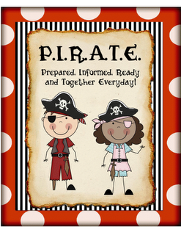

High Frequency Word List
(Be able to read by Friday)
Lesson 11
bought draw especially minute picture lose question sure worry

Homework:
Monday:
1. Math worksheet: ordering numbers.
2. Read Story from reader (sign reading log.)
3. Study spelling, vocabulary, and math facts.

Tuesday:
1. Reading: Fluency reading Day 1
2. Read Story AR book (sign reading log.)
3. Study spelling, vocabulary, and math facts.

Wedneday:
- Math worksheet: Reading number words.
- Fluency passage: Day 2
- Read AR book (sign reading log.)
- Study spelling, vocabulary, and math facts.

Thursday:
- Read AR book. (Sign reading log.)
- Fluency passage: Day 3
- Study spelling, vocabulary, and math facts for test tomorrow.

November’s Character Trait
Gratefulness
Student of the Month for October:
Respect
Naidalyn Wolf

Spelling Words
- wish
- lunch
- show
- then
- bath
- shape
- chop
- catch
- such
- each
- shadow
- starfish
- sandwich
- bathtub
- matchbox
Bonus:
- adorn
- kin
- fellow
- original
- executive

Vocabulary
- filthy: dirty.
- fellow: someone who has something in common with you.
- executive: the boss of a business.
- beautifying: to make something more beautiful than it was.
- renowned: famous for something.
- kin: all of your family members or relatives.
- original: the first of its kind.
- adorn: to decorate or make beautiful.

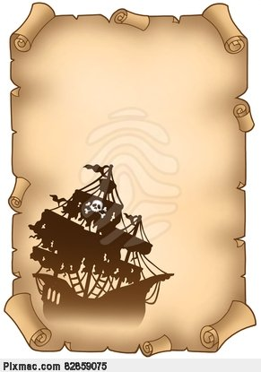

Contact Me:

twade@sperry.k12.ok.us
918-288-7213

HAVE A GREAT WEEK!

